**Inclusiveness Target Country (ITC) Application Procedure**

Summary

Read me first 1

ITC Presentation 2

ITC application documents to prepare 3

Going to e-COST for applying 3

Grant awarding board (GAB) 4

ITC reporting: Conference/Dissemination Report 5

ITC grant management 6

Annex I Application Form Template 7

Annex II Conference /Dissemination Report Template 8

Read me first

COST Action IMMUNO-model opens a call for applications for Inclusiveness Target Country (ITC) Conference to be developed under the scope of the referred Action, in the terms described in this document in ITC presentation chapter.

**The 2nd Call for ITC Applications will cover the** Grant Period from November 1st, 2023 to October 31st, 2024, included.

**Application deadlines**

* **November 1st 2023 –** **July 31st 2024**: Application for ITC open
* **Ongoing**: selected candidates will be notified
* **July 31st 2024**: deadline for submission of last ITC applications
* **September 15th 2024:** deadline for the conclusion of ITC activities, including ITC reports

The last ITC submission for this schedule will be **September 30th 2024**.

Below are listed other information and links to procedures/regulations concerning ITCs

* [Rule and Principles for COST activities](https://www.google.com/url?sa=i&rct=j&q=&esrc=s&source=web&cd=&cad=rja&uact=8&ved=0CAQQw7AJahcKEwjw5rbsr5L9AhUAAAAAHQAAAAAQAg&url=https%3A%2F%2Fwww.cost.eu%2Frules_and_principles_for_COST_A&psig=AOvVaw0t68We_nMciJcx3tquZxti&ust=1676373431194205) (level A)
* [Annotated Rules for COST Actions](https://www.google.com/url?sa=t&rct=j&q=&esrc=s&source=web&cd=&cad=rja&uact=8&ved=2ahUKEwiKlfSXsJL9AhWwTqQEHb76Dy8QFnoECBIQAQ&url=https%3A%2F%2Fwww.cost.eu%2Fuploads%2F2022%2F12%2FCOST-094-21-Annotated-Rules-for-COST-Actions-Level-C-V1.3.pdf&usg=AOvVaw3K9ov9qxped6EcZhPEY98G) (level C)
* [Rules for COST Actions (level B)](https://www.cost.eu/uploads/2021/07/COST-089-21-Level-B-rules-for-COST-Actions.pdf)
* [Grant Awarding – User Guide](http://www.cost.eu/uploads/2021/12/Grant-Awarding-userguide.pdf)

Please consult the above documents before applying for the ITC. They can also be found here: <https://www.cost.eu/funding/documents-guidelines/>

|  |
| --- |
| **The procedure is summarized as:**  **First step**: read the chapter “ITC presentation” for general information  **Second step**: before applying prepare all the necessary documents. See the chapter “ITC application documents to prepare”.  **Third step**: applicants will go to the e-COST grant application. See the chapter “Going to e-COST for applying”.  **Fourth step**: after the mission is completed applicant must upload on e-COST a report on the conference outcomes, a certificate of attendance, a book of the Conference, as well as a short report for publication in our COST action website within 30 days after the end of the ITC. See the chapter “ITC reporting”. |

ITC Presentation

**Purpose of a ITC**

ITC Conference Grants aim to support ECI and PhD students from Participating ITC to attend international science and technology related conferences, event or activity on the topic of the Action that are not organised by the COST Action:

1. for oral or poster presentation;
2. for establishing contacts for future collaboration;
3. to increase the visibility of our Action.

The COST Inclusiveness Target Country are (for more details please see the COST [Country and Organisations Table](https://www.cost.eu/uploads/2023/07/Annex-I-level-A-Country-and-Organisations-Table-Version-1.6-.pdf)):

|  |  |  |
| --- | --- | --- |
| EU Member States | EU Member States Outermost Regions* | Full Members that are not EU Member States |
| Bulgaria, Croatia, Cyprus, Czech Republic, Estonia, Greece, Hungary5, Latvia, Lithuania, Malta, Poland, Portugal, Romania, Slovakia and Slovenia | French Guiana, Guadeloupe, Martinique, Mayotte, Reunion Island and Saint-Martin (France), Azores and Madeira (Portugal), and the Canary Islands (Spain) | Albania, Armenia, Bosnia and Herzegovina, Georgia, Moldova, Montenegro, North Macedonia, Serbia, Turkey, Ukraine |

*It is important to note that for the participation of the network of proposers, the ITC status of researchers and innovators from EU Member States Outermost Regions will be counted as the EU Member State they are linked to. For example, researchers affiliated in a legal entity in e.g Guadeloupe will be counted as France (non-ITC), researchers affiliated in a legal entity in Azores will be counted as Portugal (ITC). Once the Action is approved, the researchers and innovators from these EU Member States Outermost Regions can benefit from the ITC status.

**Eligibility Criteria**

1. The Grant applicant(s) are Action participants with a primary affiliation (see Article 4.1.1.1.1 on Annotated Rules for COST Actions) to a legal entity located in a ITC country;
2. The Grant applicant is a young researcher or innovator who goes to a conference located in a different country than the country of affiliation (for Affiliation, see Article 4.1.1.1.1 on Annotated Rules for COST Actions document) for presenting a communication (oral/poster).
3. The Conference must be before September 15th, 2024;
4. The Core Group of the Immuno-model COST Action has decided to prioritize new applications. For this reason applicants that were already successful in Grant Period 1, cannot apply for another grant in this Grant Period 2. However, they may apply again in Grant period 3.

**Scope of IMMUNO-model COST Action**

The IMMUNO-model COST Action aims at fostering research and innovation in the field of preclinical immuno-oncology models with the ultimate goal of advancing in the treatment of cancer patients by improving their outcomes and quality of life. The unprecedented change that immunotherapy has represented in the treatment of cancer is best illustrated by the spectacular results obtained in previously incurable malignancies, such as metastatic melanoma. However, the widespread use of these therapies has been hindered by their limited effectiveness and associated toxicities. A better understanding on the complex interactions between tumor cells and the immune system is strictly required to address these problems, and to develop more effective and safer immunotherapies. However, one of the most important obstacles in immuno-oncology research is the scarcity of preclinical models that faithfully recapitulate human immunity and contribute to identify novel therapeutic targets, characterize biomarkers of therapeutic response and toxicity, and generate reliable data on drug synergies.

IMMUNO-model will bring together European researchers from diverse sectors (academia, clinical, industry) with the common goal of establishing a Network that endorses immuno-oncology research by specifically promoting the sharing, standardization and application of immunotherapy preclinical models. This Action will allow the implementation of a broad, creative and collaborative hub through the organization of community-building activities, the creation of synergies among European and non-European scientists, and the training of future researchers in the field. The ultimate aim of this Action is to contribute to translate novel scientific discoveries into benefits to cancer patients and the society. For further details and specific objectives, please read the Memorandum of Understanding (MoU) of IMMUNO-model COST Action:

<https://e-services.cost.eu/files/domain_files/CA/Action_CA21135/mou/CA21135-e.pdf>.

**ITC conferences should comply with the scope of the action**

ITC application documents to prepare

**Grant Application -** Template at the end of this document (Annex I)

This template has been drafted in the context of our COST Action: https://www.cost.eu/ITCConference_GrantApplication. Please follow the instructions and add also the information required in the yellow fields

**Letter of acceptance from the Conference organizing committee to present a communication.**

It is responsibility of the applicant to obtain a written agreement from the Conference organizing committee. The letter must be dated back not more than 3 months.

**File containing the material used for the communication.**

The applicant must prepare a poster or presentation slides used for the conference.

**Candidate CV**

A CV should be submitted, drafted preferably in Europass format (max. 3 pages). (A list of academic publications can be added on separate pages.)

Going to e-COST for applying

**Application Procedure**

The application procedure is legally bound to the Rules for COST Actions. Eligible ITC applicants must submit their ITC applications online by logging into e-COST (https://e-services.cost.eu) and go to https://e-services.cost.eu/activity/grants and click on “Apply for a grant”. All details for ITC grant application can be fund here: https://www.cost.eu/uploads/2018/11/Inclusiveness-Target-Countries-Conference-Grants-userguide-V2-003-Oct-2018-1.pdf

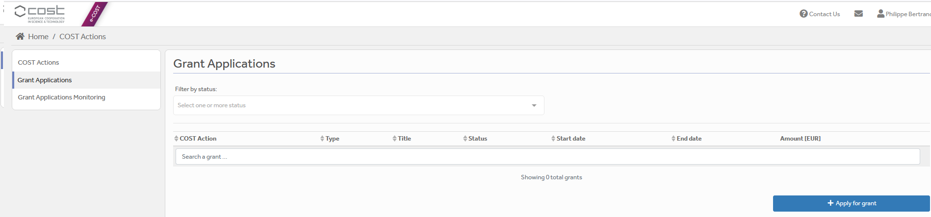

Then click on “Continue” on “ITC grant”, to encode a new application.

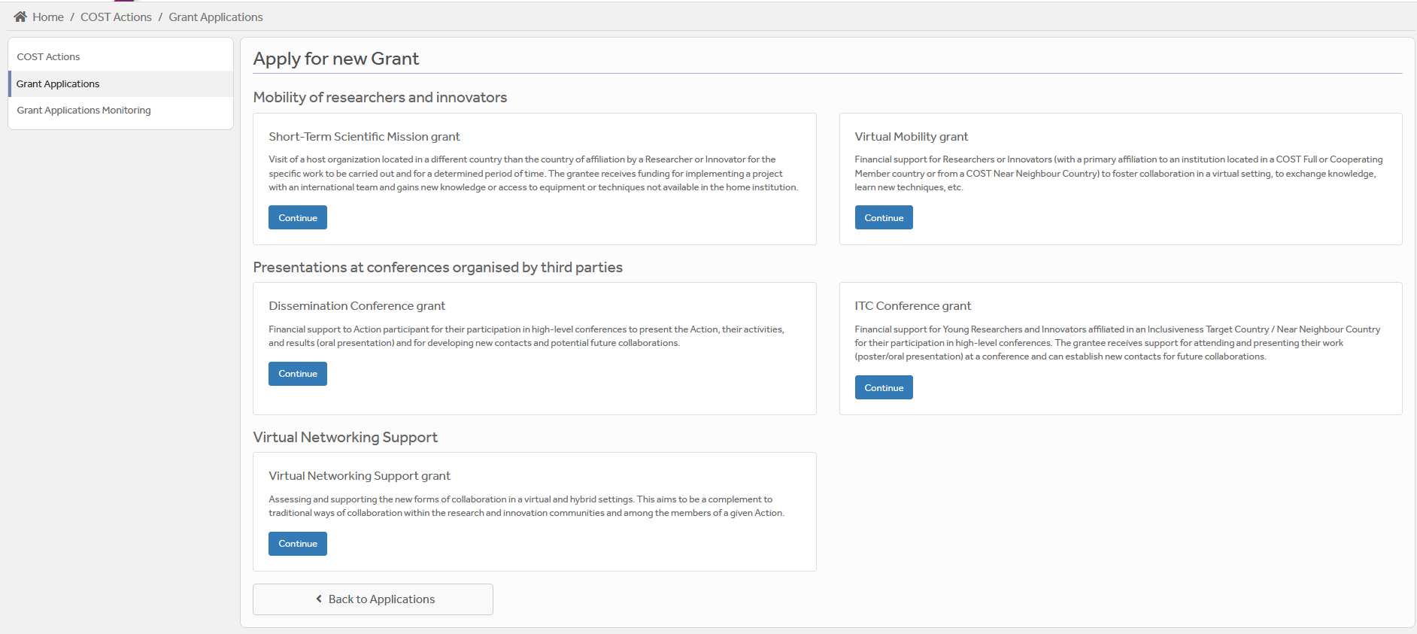

Then you just need to fill the online form with the following information:

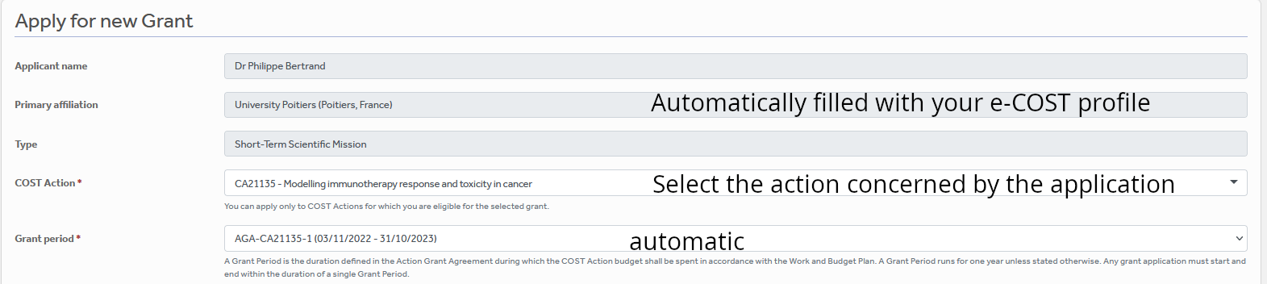

ITC



After “Save Draft” you reach the “Supporting documents” page. Here you need to mention the title of the file you will submit, the type and upload the file. Upload all the requested documents that includes:

* The Grant application form modified
* A CV
* Letter of acceptance from the Conference Organizing Committee
* Copy of the abstract of the accepted oral or poster presentation
* Material used for the communication.

Once all the documents are loaded, the applicant should click on “**Submit**”, a new window will appear and clicking on “**Options**”, please “**download PDF**”.

Grant awarding board (GAB)

The GAB is composed of the **Grant Awarding Coordinator** (Dr. Philippe Bertrand, [Philippe.bertrand@univ-poitiers.fr](mailto:Philippe.bertrand@univ-poitiers.fr)) and representatives of the working groups. It is mandatory to select the working groups the application is related to in the additional information part of the modified grant application template as reviewers of the application will be selected in the same working group(s).

The GAB will perform the scientific assessment of the applications considering the IMMUNO-model Action scope and objectives, as well as the potential for enhancement of the research interaction between the involved parts, measured by the impact of the exchange expected by the applicants and involved institutions.

The selection of applicants is based on the scientific scope of the ITC application which must be coherent with the overall objectives of the Action. The GAB will select the successful applications.

In case of conflict of interest (i.e. applicant belonging to a commissioner’s research group), the member that is constrained in their duties will be substituted by the Action Chair or the Vice-Chair.

General criteria for evaluation of ITC proposals are:

* Priority to PhD students and post-docs until 2 years after the completion of the PhD.;
* Applicants must be from ITCs;
* Gender balance;
* Quality of the communication material;
* Main expected networking activities during the conference and their contribution to the progress towards the Action objectives and deliverables;
* Curriculum Vitae (CV).

**The Grant Holder will inform each approved applicant by sending a Grant Letter generated from e-COST. The applicant must return this letter of acceptance with his/her signature.**

ITC reporting: Conference/Dissemination Report

**A template for the report can be found at the end of this document (Annex II).**

**This template has been drafted from (https://www.cost.eu/ITCConference_Report) in the context of our COST Action: Please follow the instructions. It should be uploaded as a word file on e-COST, not a pdf.**

**ITC Conference report**

The report must be uploaded, **within 30 days from the end date of the Conference via e-COST tool**. Other documents to be provided are:

A certificate of attendance;

The programme of the conference or book of abstracts / proceedings indicating the presentation (oral or poster) of the grantee must be obtained by the grantee during the conference.

**The networking report is drafted by the applicant (see Annex II).**

When preparing the scientific report please consider the following:

* The networking report for COST is a public document. Please take this into account in terms of Intellectual Property Rights.
* The report should focus on the networking aspects, in particular how contacts for future collaborative research have been managed to strengthen the scientific relationship between the grantee and other people present at the conference within the framework of Cooperation and Science in the European Union.

**ITC dissemination report**

**To be included in the Conference report (see Annex II for ideas on items to provide) or send the items directly to the Working Group 5 Leader Barbara Breznik (barbara.breznik@nib.si) and to Working Group 5 Co-leader Rosalinda Sorrentino (**[**rsorrentino@unisa.it**](mailto:rsorrentino@unisa.it)**) within 30 days after the end of your ITC conference.**

A s**hort blog / success story (3-4 sentences) /video (max. 1 minute)** describing the subject of your communication including **a strong advertising sentence** summarizing your ITC Conference experience. This material will be used for promotion of our COST action in our web site and social media.

Your **credentials in social media** (if you have such) to tag you in publication of your post.

Please remember to present your passion for science! Use pictures showing you at work but also after-work. Do not sound too abstract, avoid scientific jargon, use short sentences. The material is to advertise IMMUNO-MODEL COST research, promote you, and will be shown in social media for public audience.

**Failure to submit the Conference & dissemination report materials, certificate of attendance and book of the Conference within 30 days from the end date of the Conference will effectively cancel the Grant.**

***By applying for this grant, the participant acknowledges that he/she is aware that his/her data and dissemination material will be collected, stored, processed and used for the purposes of the activities of the IMMUNO-model COST action CA21135 in accordance with the General Data Protection Regulation (GDPR).***

ITC grant management

Prepare your budget with the Excel tool provided in the modified Grant application template (Annex I). Each successful ITC applicant will be granted based on a fixed amount.

An ITC Grant is a fixed financial contribution which takes into consideration the budget request of the applicant and the outcome of the evaluation of the ITC application (max 2000 euros, virtual 500 euros). **Please note that ITC Grants do not necessarily cover all expenses related to undertaking a given mission**, being only a contribution to the overall travel, accommodation and meal expenses of the Grantee. Applicants are encouraged to evaluate their budget request based on a high benefit/cost ratio and justify it based on the perceived cost of living in the host country/city. Applicant should use the Excel tool provided in the modified Grant application form.

ITC grantees should make their own arrangements for all provisions related to personal security, health, taxation, social security and pension matters.

Grants are paid by the Grant Holder Institution after the completion of the activity and approval of all required report/documentation. Within 30 days from the end date of the ITC Conference (or 15 days after the end of the Grant Period, whichever date comes first), the successful applicant must submit the **Conference report,** the **dissemination materials** and the **certificate of attendance.** These documents must be uploaded on e-COST to proceed with the request for payment.

**Pre-payment**

ITCs grantees may request up **to 50% pre-payment of the approved grant.** This amount is subject to availability of funds and approval by the Grant Holder Institution. The request of pre-payment shall be submitted to the Grant Holder Manager ([ghm_immunomodel@igtp.cat](mailto:ghm_immunomodel@igtp.cat)) and the Grant Awarding Coordinator (Dr. Philippe Bertrand, [Philippe.bertrand@univ-poitiers.fr](mailto:Philippe.bertrand@univ-poitiers.fr)).

**ITC contacts**

|  |  |
| --- | --- |
| **Dr. Philippe Bertrand**  **CA21135 Grant Awarding Coordinator**  Institute of Chemistry for Media and Material  University of Poitiers  4 rue Michel Brunet TSA 51106  86073 Poitiers cedex 9  France  **Philippe.bertrand@univ-poitiers.fr** | **Prof. Dr Leticia Oliveira-Ferrer**  **CA21135 Action Vice-Chair**  Department of Gynecology  University Medical Center Hamburg-Eppendorf  Martinistrasse 52  20246 Hamburg  Germany  **ferrer@uke.de** |

Annex I Application Form Template

**Action number:**

**Applicant name:**

|  |
| --- |
| **Conference Details**  Conference title:  Conference web-page:  Conference venue (For an online conference, specify virtual participation; for hybrid conferences, specify whether it is an in-person or virtual participation ):  Conference start and end date: DD/MM/YYYY to DD/MM/YYYY |
| **Accepted contribution details**  Title of the presentation:  Type of the presentation: (oral/poster)  Co-authors:  Other details of the presentation: specify here any additional details related to the contribution (e.g. title of the session / track of the conference programme in which the contribution is accepted) |
| **Relevance of the Conference topic to the Action**  Description of the relevance of the Conference to the Action (e.g., MoU objective, deliverable or WG task).  *(max.500 word)*  Applicant enters max. 500 word summary here. |
| **Motivation and expected impact**  Description of the applicant’s motivation to participate in the conference and potential impact on the applicant’s career.  *(max.500 word)*  Applicant enters max. 500 word summary here. |
| **Additional information requested by the Grant Awarding Board for the evaluation process. In case these information are not provided the application can be cancelled by the board.** |
| **Working groups in relation to the project** [1] [2] [3] [4] [5] (select 2 max)  WG1 – In vitro and ex vivo cancer immunotherapy models  WG2 – In vivo cancer immunotherapy models.  WG3 – Solid tumors.  WG4 – Hematologic tumors  WG5 – Communication, events and partnering with industry.  For objectives of the working groups, please read the Memorandum of understanding: <https://e-services.cost.eu/files/domain_files/CA/Action_CA21135/mou/CA21135-e.pdf>.  Please include how the planned communication will contribute to the plan of one or more WG(s) of the Action. |
| **Estimated budget plan:** The applicant is requested to define a budget to explain the requested amount. An example is provided below for 1 month mission. The budget must consider shorter or longer stays. Asking 2000 euros for one week is not reasonable.  Double-click the table to edit the embedded excel sheet. Fill only greyed boxes. Current data are to illustrate the automatic calculation. (If not working contact Philippe.bertrand@univ-poitiers.fr) |

Annex II Conference/Dissemination Report Template

**Action number:**

**Grantee name:**

|  |  |
| --- | --- |
| **Conference Details**  Conference title:  Conference web-page:  Conference venue(For an online conference, specify virtual participation; for hybrid conferences, specify whether it is an in-person or virtual participation ):  Conference start and end date: DD/MM/YYYY to DD/MM/YYYY | |
| **Accepted contribution details**  Title of the presentation:  Type of the presentation: (oral/poster)  Co-authors:  Other details of the presentation: specify here any additional details related to the contribution (e.g. title of the session / track of the conference programme in which the contribution is accepted) | |
| **Outcome of the conference participation** | |
| Description of the outcome of the presentation of the accepted contribution, in terms of grantee’s visibility, including the establishment of new contacts for future collaborations  *(max.500 word)*  Applicant enters max. 500 word summary here. | |
| **Acknowledgement of inclusion of necessary supporting documents to claim the grant**  I confirm that the following documents have been uploaded on e-COST as an integral part of this report:  - the certificate of conference attendance.  - the programme of the conference or book of abstracts / proceedings indicating the presentation (oral or poster) of the grantee.  - copy of the given presentation (oral or poster). | |
| **Short report for dissemination purposes. Examples of items to be added in the scientific report or send directly to Barbara Breznik (barbara.breznik@nib.si) and Rosalinda Sorrentino (rsorrentino@unisa.it)**  ***The participant acknowledges that he/she is aware that his/her data and dissemination material will be collected, stored, processed and used for the purposes of the activities of the IMMUNO-model COST action CA21135 in accordance with the General Data Protection Regulation (GDPR).*** | |
| short blog / success story (3-4 sentences) | |
| Examples of pictures to add | |
| Add picture caption: Myself at Conference X…. | Add caption: Myself giving a seminar/conference/in front of my poster…at Conference X… |
| Link to material to be downloaded (e.g. powerpoint, videos, pictures at high resolution…) | |
| credentials in social media, if applicable | |