**Dissemination Conference (DC) Application Extended**

Summary

Read me first 1

DC Presentation 2

DC application documents to prepare 3

Going to e-COST for applying 3

Grant awarding board (GAB) 4

DC reporting: Conference/Dissemination Report 5

DC grant management 6

Annex I Application Form Template 7

Annex II Conference/Dissemination Report Template 8

Read me first

COST Action IMMUNO-model opens a call for applications for Dissemination Conference (DC) to be developed under the scope of the referred Action, in the terms described in this document in DC presentation chapter.

**The Extended Call for DC Applications will cover the** Grant Period from **September 23 2024 –** **October 21st 2024**, included.

**Application deadlines**

* **September 23 2024 –** **October 21st 2024**: Extended application for DC open
* **Ongoing**: selected candidates will be notified
* **Submission on the fly**
* **October 23 2024:** deadline for the conclusion of DC activities, including DC reports

Below are listed other information and links to procedures/regulations concerning DCs

* [Rule and Principles for COST activities](https://www.google.com/url?sa=i&rct=j&q=&esrc=s&source=web&cd=&cad=rja&uact=8&ved=0CAQQw7AJahcKEwjw5rbsr5L9AhUAAAAAHQAAAAAQAg&url=https%3A%2F%2Fwww.cost.eu%2Frules_and_principles_for_COST_A&psig=AOvVaw0t68We_nMciJcx3tquZxti&ust=1676373431194205) (level A)
* [Annotated Rules for COST Actions](https://www.google.com/url?sa=t&rct=j&q=&esrc=s&source=web&cd=&cad=rja&uact=8&ved=2ahUKEwiKlfSXsJL9AhWwTqQEHb76Dy8QFnoECBIQAQ&url=https%3A%2F%2Fwww.cost.eu%2Fuploads%2F2022%2F12%2FCOST-094-21-Annotated-Rules-for-COST-Actions-Level-C-V1.3.pdf&usg=AOvVaw3K9ov9qxped6EcZhPEY98G) (level C)
* [Rules for COST Actions (level B)](https://www.cost.eu/uploads/2021/07/COST-089-21-Level-B-rules-for-COST-Actions.pdf)
* [Grant Awarding – User Guide](http://www.cost.eu/uploads/2021/12/Grant-Awarding-userguide.pdf)

Please consult the above documents before applying for the DC. They can also be found here: <https://www.cost.eu/funding/documents-guidelines/>

|  |
| --- |
|  |

|  |
| --- |
|  |

DC Presentation

**Purpose of a DC**

Dissemination Conference consists in an oral presentation by an Action Participant of the work of the Action in high-level conferences fully organized by a third party, i.e. not organized nor co-organized by the COST Action:

Dissemination Conference:

* Significantly increase visibility of the Action in the research community, can contribute to increasing visibility of the presenter;
* Attract additional participants and stakeholders and disseminate Action results to relevant end-users at high profile conferences in the field on a topic relevant to the Action.

Dissemination Conference benefits to:

* Dissemination Conference Grantee: receives support for attending and delivering an oral presentation of the Action, their activities, results at a conference and for developing new contacts and potential future collaborations, actively networks with other participants and promotes the COST Action to the potential stakeholders;
* COST Action: receives increased visibility and awareness, new contacts with potential stakeholders.

**Eligibility Criteria**

1. The Grant applicant(s) are Action participants with a primary affiliation (see Article 4.1.1.1.1 on Annotated Rules for COST Actions) to a legal entity located in a COST country;
2. The Grant applicant is preferably a confirmed researcher who goes to a conference located in a different country than the country of affiliation (for Affiliation, see Article 4.1.1.1.1 on Annotated Rules for COST Actions document) for presenting an oral communication.
3. The Conference must take place between **September 23 2024 –** **October 21st 2024**;
4. The Core Group of the Immuno-model COST Action has decided to prioritize new applications. For this reason applicants that were already successful in Grant Period 1, cannot apply for another grant in this Grant Period 2. However, they may apply again in Grant period 3.

**Scope of IMMUNO-model COST Action**

The IMMUNO-model COST Action aims at fostering research and innovation in the field of preclinical immuno-oncology models with the ultimate goal of advancing in the treatment of cancer patients by improving their outcomes and quality of life.

The unprecedented change that immunotherapy has represented in the treatment of cancer is best illustrated by the spectacular results obtained in previously incurable malignancies, such as metastatic melanoma. However, the widespread use of these therapies has been hindered by their limited effectiveness and associated toxicities. A better understanding on the complex interactions between tumor cells and the immune system is strictly required to address these problems, and to develop more effective and safer immunotherapies. However, one of the most important obstacles in immuno-oncology research is the scarcity of preclinical models that faithfully recapitulate human immunity and contribute to identify novel therapeutic targets, characterize biomarkers of therapeutic response and toxicity, and generate reliable data on drug synergies.

IMMUNO-model will bring together European researchers from diverse sectors (academia, clinical, industry) with the common goal of establishing a Network that endorses immuno-oncology research by specifically promoting the sharing, standardization and application of immunotherapy preclinical models. This Action will allow the implementation of a broad, creative and collaborative hub through the organization of community-building activities, the creation of synergies among European and non-European scientists, and the training of future researchers in the field. The ultimate aim of this Action is to contribute to translate novel scientific discoveries into benefits to cancer patients and the society. For further details and specific objectives, please read the Memorandum of Understanding (MoU) of IMMUNO-model COST Action:

<https://e-services.cost.eu/files/domain_files/CA/Action_CA21135/mou/CA21135-e.pdf>.

**DC conferences should comply with the scope of the action**

DC application documents to prepare

**Grant Application -** Template at the end of this document (Annex I)

This template has been drafted in the context of our COST Action: https://www.cost.eu/DisseminationConference_GrantApplication. Please follow the instructions and add also the information required in the yellow fields.

**Letter of acceptance from the Conference organizing committee to present an oral communication.**

It is responsibility of the applicant to obtain a written agreement from the Conference organizing committee. The letter must be dated back not more than 3 months.

**Copy of the abstract of the accepted oral presentation**

**File containing the material used for the communication.**

The applicant must prepare a presentation slides used for the conference.

**Candidate CV**

A CV should be submitted, drafted preferably in Europass format (max. 3 pages). (A list of academic publications can be added on separate pages.)

Going to e-COST for applying

**Application Procedure**

The application procedure is legally bound to the Rules for COST Actions. Eligible DC applicants must submit their DC applications online by logging into e-COST (https://e-services.cost.eu) and go to https://e-services.cost.eu/activity/grants and click on “Apply for a grant”.

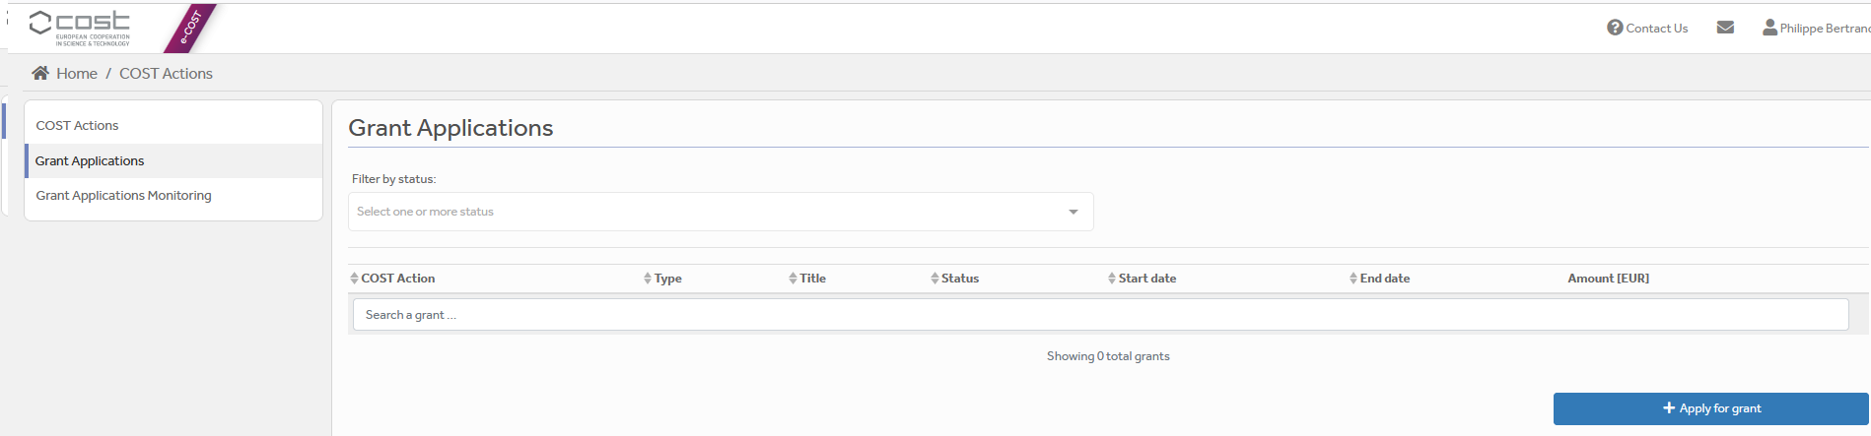

Then click on “Continue” on “DC grant”, to encode a new application.

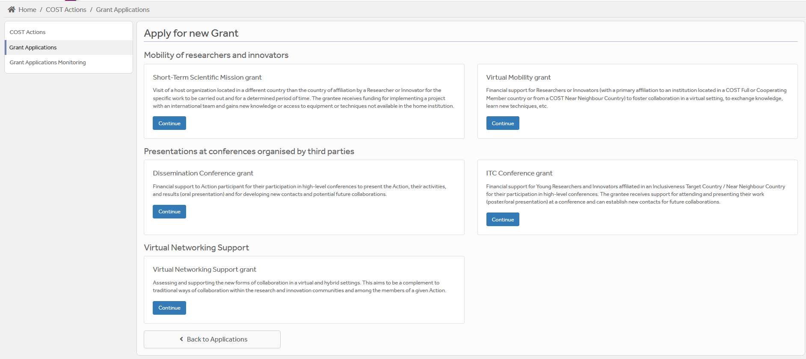

Then you just need to fill the online form with the following information:

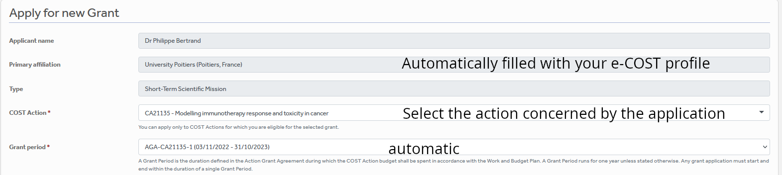

DC



After “Save Draft” you reach the “Supporting documents” page. Here you need to mention the title of the file you will submit, the type and upload the file. Upload all the requested documents that includes:

* The Grant application form modified,
* A CV,
* Letter of acceptance from the Conference Organizing Committee,
* Copy of the abstract of the accepted oral presentation
* Material used for the communication.

Once all the documents are loaded, the applicant should click on “**Submit**”, a new window will appear and clicking on “**Options**”, please “**download PDF**”.

Grant awarding board (GAB)

The GAB is composed of the **Grant Awarding Coordinator** (Dr. Philippe Bertrand, [Philippe.bertrand@univ-poitiers.fr](mailto:Philippe.bertrand@univ-poitiers.fr)) and representatives of the working groups. It is mandatory to select the working groups the application is related to in the additional information part of the modified grant application template as reviewers of the application will be selected in the same working group(s).

The GAB will perform the scientific assessment of the applications considering the IMMUNO-model Action scope and objectives, as well as the potential for enhancement of the research interaction between the involved parts, measured by the impact of the exchange expected by the applicants and involved institutions.

The selection of applicants is based on the scientific scope of the DC application which must be coherent with the overall objectives of the Action. The GAB will select the successful applications.

In case of conflict of interest (i.e. applicant belonging to a commissioner’s research group), the member that is constrained in their duties will be substituted by the Action Chair or the Vice-Chair.

General criteria for evaluation of DC proposals are:

* Principal investigators;
* Gender balance;
* Quality of the communication material;
* Main expected networking activities during the conference and their contribution to the progress towards the Action objectives and deliverables;

**The Grant Holder will inform each approved applicant by sending a Grant Letter generated from e-COST. The applicant must return this letter of acceptance with his/her signature.**

DC reporting: Conference/Dissemination Report

**A template for the report can be found at the end of this document (Annex II).**

**This template has been drafted from (https://www.cost.eu/DisseminationConference_Report) in the context of our COST Action: Please follow the instructions. It should be uploaded as a word file on e-COST, not a pdf.**

**DC Conference report**

The report must be uploaded, **within 30 days from the end date of the Conference and before October 23 2024 via e-COST tool**. Other documents to be provided are:

* A certificate of attendance;
* The programme of the conference or book of abstracts / proceedings indicating the presentation (oral or poster) of the grantee must be obtained by the grantee during the conference.

**The networking report is drafted by the applicant (see Annex II).**

When preparing the scientific report please consider the following:

* The networking report for COST is a public document. Please take this into account in terms of Intellectual Property Rights.
* The report should focus on the networking aspects, in particular how contacts for future collaborative research have been managed to strengthen the scientific relationship between the grantee and other people present at the conference within the framework of Cooperation and Science in the European Union.

**DC dissemination report**

**To be included in the Conference report (see Annex II for ideas on items to provide) or send the items directly to the Working Group 5 Leader Barbara Breznik (barbara.breznik@nib.si) and to Working Group 5 Co-leader Rosalinda Sorrentino (**[**rsorrentino@unisa.it**](mailto:rsorrentino@unisa.it)**) within 30 days after the end of your Dissemination Conference** **and before October 23 2024**

A s**hort blog / success story (3-4 sentences) /video (max. 1 minute)** describing the subject of your communication including **a strong advertising sentence** summarizing your DC experience. This material will be used for promotion of our COST action in our web site and social media.

Your **credentials in social media** (if you have such) to tag you in publication of your post.

Please remember to present your passion for science! Use pictures showing you at work but also after-work. Do not sound too abstract, avoid scientific jargon, use short sentences. The material is to advertise IMMUNO-MODEL COST research, promote you, and will be shown in social media for public audience.

**Failure to submit the Conference & dissemination report materials, certificate of attendance, presentation and book of the Conference within 30 days from the end date of the Conference or after October 23 2024 will effectively cancel the Grant.**

***By applying for this grant, the participant acknowledges that he/she is aware that his/her data and dissemination material will be collected, stored, processed and used for the purposes of the activities of the IMMUNO-model COST action CA21135 in accordance with the General Data Protection Regulation (GDPR).***

DC grant management

Prepare your budget with the Excel tool provided in the modified Grant application template (Annex I). Each successful DC applicant will be granted based on a fixed amount.

A DC Grant is a fixed financial contribution which takes into consideration the budget request of the applicant and the outcome of the evaluation of the DC application (max 2000 euros, virtual 500 euros). **Please note that DC Grants do not necessarily cover all expenses related to undertaking a given mission**, being only a contribution to the overall travel, accommodation and meal expenses of the Grantee. Applicants are encouraged to evaluate their budget request based on a high benefit/cost ratio and justify it based on the perceived cost of living in the host country/city. Applicant should use the Excel tool provided in the modified Grant application form.

DC grantees should make their own arrangements for all provisions related to personal security, health, taxation, social security and pension matters.

Grants are paid by the Grant Holder Institution after the completion of the activity and approval of all required report/documentation. Within 30 days from the end date of the DC Conference (or 15 days after the end of the Grant Period, whichever date comes first), the successful applicant must submit the **Conference report,** the **dissemination materials** and the **certificate of attendance.** These documents must be uploaded on e-COST to proceed with the request for payment.

**Pre-payment**

DCs grantees may request up **to 50% pre-payment of the approved grant.** This amount is subject to availability of funds and approval by the Grant Holder Institution. The request of pre-payment shall be submitted to the Grant Holder Manager ([ghm_immunomodel@igtp.cat](mailto:ghm_immunomodel@igtp.cat)) and the Grant Awarding Coordinator (Dr. Philippe Bertrand, [Philippe.bertrand@univ-poitiers.fr](mailto:Philippe.bertrand@univ-poitiers.fr)).

**DC contacts**

|  |  |
| --- | --- |
| **Dr. Philippe Bertrand**  **CA21135 Grant Awarding Coordinator**  Institute of Chemistry for Media and Material  University of Poitiers  4 rue Michel Brunet TSA 51106  86073 Poitiers cedex 9  France  **Philippe.bertrand@univ-poitiers.fr** | **Prof. Dr Leticia Oliveira-Ferrer**  **CA21135 Action Vice-Chair**  Department of Gynecology  University Medical Center Hamburg-Eppendorf  Martinistrasse 52  20246 Hamburg  Germany  **ferrer@uke.de** |

Annex I Application Form Template

**Action number:**

**Applicant name:**

|  |
| --- |
| **Conference Details**  Conference title:  Conference web-page:  Conference venue[1]:  Conference start and end date: DD/MM/YYYY to DD/MM/YYYY |
| **Accepted oral contribution details**  Title of the presentation:  Co-authors:  Other details of the presentation: specify here any additional details related to the contribution (e.g. title of the session / track of the conference programme in which the contribution is accepted) |
| **Alignment with the Action Science Communication Plan**  Description on how the presentation contributes to the Action Science Communication Plan and to meeting the Action challenge and objectives. Description of the targeted audience and potential stakeholders to engage.  *(max.500 word)*  Applicant enters max. 500 word summary here. |
| **Expected impact**  Description of the expected impacts to increase the Action visibility in the research community; to attract additional participants and stakeholders; and to disseminate Action results to relevant end-users. |
| *(max.500 word)*  Applicant enters max. 500 word summary here. |
| **Additional information requested by the Grant Awarding Board for the evaluation process. In case these information are not provided the application can be cancelled by the board.** |
| **Working groups in relation to the project** [1] [2] [3] [4] [5] (select 2 max)  WG1 – In vitro and ex vivo cancer immunotherapy models  WG2 – In vivo cancer immunotherapy models.  WG3 – Solid tumors.  WG4 – Hematologic tumors  WG5 – Communication, events and partnering with industry.  For objectives of the working groups, please read the Memorandum of understanding: <https://e-services.cost.eu/files/domain_files/CA/Action_CA21135/mou/CA21135-e.pdf>.  Please include how the planned communication will contribute to the plan of one or more WG(s) of the Action. |
| **Estimated budget plan:** The applicant is requested to define a budget to explain the requested amount. An example is provided below for 1 month mission. The budget must consider shorter or longer stays. Asking 2000 euros for one week is not reasonable.  Double-click the table to edit the embedded excel sheet. Fill only greyed boxes. Current data are to illustrate the automatic calculation. (If not working contact Philippe.bertrand@univ-poitiers.fr) |

Annex II Conference/Dissemination Report Template

**Action number:**

**Grantee name:**

|  |  |
| --- | --- |
| **Conference Details**  Conference title:  Conference web-page:  Conference venue[2]:  Conference start and end date: DD/MM/YYYY to DD/MM/YYYY  **Accepted oral contribution details**  Title of the presentation:  Co-authors:  Other details of the presentation: specify here any additional details related to the contribution (e.g. title of the session / track of the conference programme in which the contribution is accepted) | |
| **Outcome of the conference participation**  Description of the outcome of the conference presentation, including contacts made and potential for future collaborations.  *(max.500 word)*  Applicant enters max. 500 word summary here. | |
| **Acknowledgement of inclusion of necessary supporting documents to claim the grant** | |
| ­I confirm that the following documents have been uploaded on e-COST as an integral part of this report:   * the certificate of conference attendance. * the programme of the conference or book of abstracts / proceedings indicating the oral presentation of the grantee. * copy of the given presentation. | |
| **Short report for dissemination purposes. Examples of items to be added in the scientific report or send directly to Barbara Breznik (barbara.breznik@nib.si) and Rosalinda Sorrentino (rsorrentino@unisa.it).**  ***The participant acknowledges that he/she is aware that his/her data and dissemination material will be collected, stored, processed and used for the purposes of the activities of the IMMUNO-model COST action CA21135 in accordance with the General Data Protection Regulation (GDPR).*** | |
| short blog / success story (3-4 sentences) | |
| Examples of pictures to add | |
| Add picture caption: Myself at Conference X…. | Add caption: Myself giving a seminar/conference/in front of my poster…at Conference X… |
| Link to material to be downloaded (e.g. powerpoint, videos, pictures at high resolution…) | |
| credentials in social media, if applicable | |

1. For an online conference, specify virtual participation; for hybrid conferences, specify whether it is an in-person or virtual participation.
2. For an online conference, specify virtual participation; for hybrid conferences, specify whether it is an in-person or virtual participation.