**Short-Term Scientific Missions (STSM) Application Extended**

Summary

Read me first 1

STSM Presentation 1

STSM application documents to prepare 3

Going to e-COST for applying 3

Grant awarding board (GAB) 4

STSM reporting: Scientific Report and short report for dissemination purposes 5

STSM grant management 6

Annex I Application Form Template 7

Annex II Scientific Report Template 9

Read me first

COST Action IMMUNO-model opens a call for applications for Short-Term Scientific Missions (STSM) to be developed under the scope of the referred Action, in the terms described in this document in STSM presentation chapter.

**The extended call for Grant Period 2 (GP2) will cover September 23 2024 –** **October 21st 2024**, included.

**Application deadlines for the extended call**

* **September 23 2024 –** **October 21st 2024**: Extended application for STSM open
* **Ongoing**: selected candidates will be notified
* **Submission on the fly**
* **October 23 2024:** deadline for the conclusion of STSM activities, including STSM reports

Below are listed other information and links to procedures/regulations concerning STSMs

* [Rule and Principles for COST activities](https://www.cost.eu/uploads/2021/07/COST-088-21-Level-A-Rules-and-Principles-for-COST-Activities.pdf) (level A)
* [Annotated Rules for COST Actions](https://www.cost.eu/uploads/2023/11/COST-094-21-Annotated-Rules-for-COST-Actions-Level-C-V1.4-Final-.pdf) (level C)
* [Rules for COST Actions (level B)](https://www.cost.eu/uploads/2021/07/COST-089-21-Level-B-rules-for-COST-Actions.pdf)
* [Grant Awarding – User Guide](http://www.cost.eu/uploads/2021/12/Grant-Awarding-userguide.pdf)

Please consult the above documents before applying for the STSM. They can also be found here: <https://www.cost.eu/funding/documents-guidelines/>

|  |
| --- |
| **The procedure is summarized as:**  **First step**: read the chapter “STSM presentation” for general information  **Second step**: before applying prepare all the necessary documents. See the chapter “STSM  application documents to prepare”.  **Third step**: applicants will go to the e-COST grant application. See the chapter “Going to e-COST for  applying”.  **Fourth step**: after the mission is completed applicant must upload on e-COST a scientific report  approved by a scientist from the host institution as well as a short report for publication in our COST  action website within 30 days after the end of the STSM. See the chapter “STSM reporting”. |

STSM Presentation

**Purpose of a STSM**

Short-Term Scientific Missions are visits of a **researcher** or **innovator** to **a host organization** located in a different country than the country of affiliation (for Affiliation, see Article 4.1.1.1.1 on Annotated Rules for COST Actions document) for specific work to be carried out and for a determined period of time. STSMs are valuable:

1. for the STSM Grantee, who has the chance to receive funding for implementing a project with an international team, obtaining new knowledge or access to equipment or techniques not available in the home institution;
2. for the STSM Host who can receive an international partner in their institution and extend or create a long-lasting collaboration. STSMs support specific / general topic(s) that can help achieve the Action MoU objectives and deliverables (research coordination). A STSM should specifically contribute to the scientific objectives of the COST Action, helping to achieve the Action MoU objectives and deliverables.

**Eligibility Criteria**

1. The Grant applicant(s) are Action participants with a primary affiliation (see Article 4.1.1.1.1 on Annotated Rules for COST Actions) to a legal entity located in a COST Full or Cooperating Member country, a COST Near Neighbour Country or a European RTD Organization;
2. The Grant applicant is a researcher or innovator who visits a host organizationlocated in a different country than the country of affiliation (for Affiliation, see Article 4.1.1.1.1 on Annotated Rules for COST Actions document) for specific work to be carried out and for a determined period of time;
3. The STSM must have a minimum duration of 5 calendar days (including travel) and conclude between **September 23 2024 –** **October 21st 2024**;
4. The COST Association and the Grant Holder of the Action cannot be considered as being an STSM grantee’s employer, i.e. the STSM Grant cannot be considered as a salary;
5. The Core Group of the Immuno-model COST Action has decided to prioritize new applications. For this reason applicants that were already successful in Grant Period 1, cannot apply for another grant in this Grant Period 2. However, they may apply again in Grant period 3.

**Scope of IMMUNO-model COST Action**

The IMMUNO-model COST Action aims at fostering research and innovation in the field of preclinical immuno-oncology models with the ultimate goal of advancing in the treatment of cancer patients by improving their outcomes and quality of life.

The unprecedented change that immunotherapy has represented in the treatment of cancer is best illustrated by the spectacular results obtained in previously incurable malignancies, such as metastatic melanoma. However, the widespread use of these therapies has been hindered by their limited effectiveness and associated toxicities. A better understanding on the complex interactions between tumor cells and the immune system is strictly required to address these problems, and to develop more effective and safer immunotherapies. However, one of the most important obstacles in immuno-oncology research is the scarcity of preclinical models that faithfully recapitulate human immunity and contribute to identify novel therapeutic targets, characterize biomarkers of therapeutic response and toxicity, and generate reliable data on drug synergies.

IMMUNO-model will bring together European researchers from diverse sectors (academia, clinical, industry) with the common goal of establishing a Network that endorses immuno-oncology research by specifically promoting the sharing, standardization and application of immunotherapy preclinical models. This Action will allow the implementation of a broad, creative and collaborative hub through the organization of community-building activities, the creation of synergies among European and non-European scientists, and the training of future researchers in the field. The ultimate aim of this Action is to contribute to translate novel scientific discoveries into benefits to cancer patients and the society.

For further details and specific objectives, please read the Memorandum of Understanding (MoU) of IMMUNO-model COST Action:

<https://e-services.cost.eu/files/domain_files/CA/Action_CA21135/mou/CA21135-e.pdf>.

**STSM should comply with the scope of the action**

STSM application documents to prepare

**Grant Application -** Template at the end of this document (Annex I). **Using this template is mandatory.** This template has been drafted from <https://www.cost.eu/STSM_GrantApplication> in the context of our COST Action: Please follow the instructions and add also the information required in the yellow fields

**Invitation letter from the Host Institution**

It is the responsibility of the applicant to obtain **a signed written** agreement from the Host institution stating that the applicant may perform the activities detailed in the STSM working plan on the agreed dates. The letter must be dated back not more than 3 months, and must be signed by a permanent staff representative of the Host institution (e.g. head of the research group, PI, director of the department, head of the institute/division etc.)

**Candidate CV**

A CV should be submitted, drafted preferably in Europass format (max. 3 pages). (A list of academic publications can be added on separate pages.)

Going to e-COST for applying

**Application Procedure**

The application procedure is legally bound to the Rules for COST Actions. Eligible STSM applicants must submit their STSM applications online by logging into e-COST (https://e-services.cost.eu) and go to https://e-services.cost.eu/activity/grants and click on “Apply for a grant”.

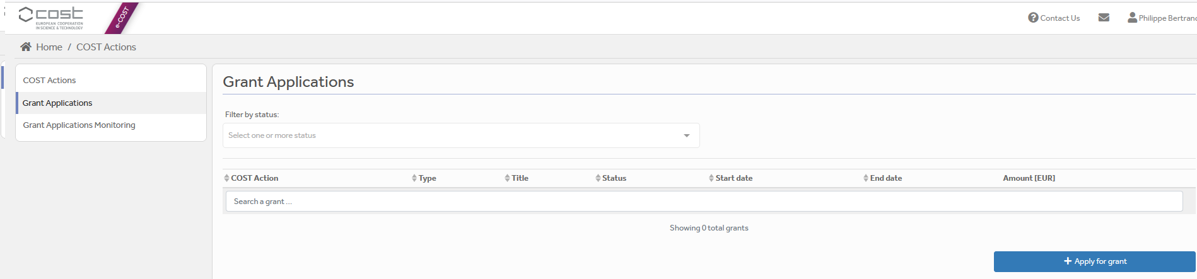

Then click on “Continue” on “Short-Term Scientific Mission grant”, to encode a new application.

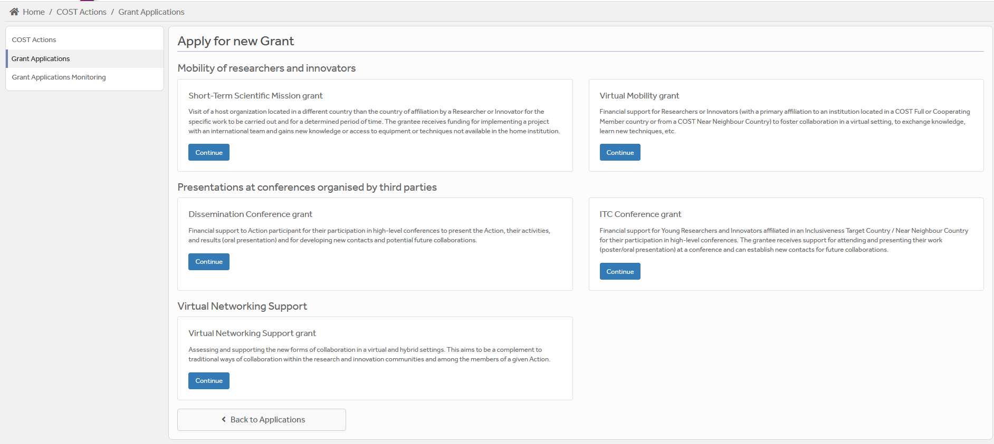

Then you just need to fill the online form with the following information:

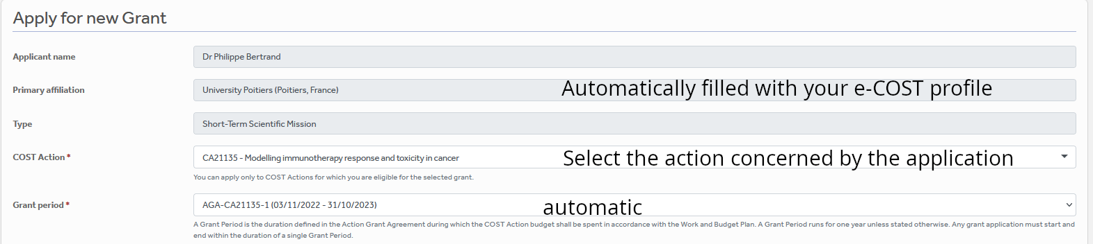

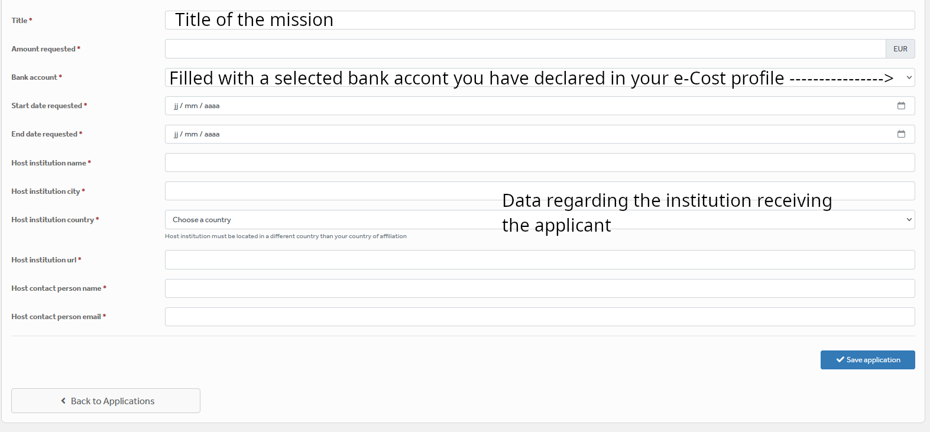

After “Save Draft” you reach the “Supporting documents” page. Here you need to mention the title of the file you will submit, the type and upload the file. Upload all the requested documents that includes:

* The Grant application form modified,
* A CV,
* Invitation letter from the Host, signed.

Once all the documents are loaded, the applicant should click on “**Submit**”, a new window will appear and clicking on “**Options**”, please “**download PDF**”.

Grant awarding board (GAB)

The GAB is composed of the **Grant Awarding Coordinator** (Dr. Philippe Bertrand, [Philippe.bertrand@univ-poitiers.fr](mailto:Philippe.bertrand@univ-poitiers.fr)) and representatives of the working groups. It is mandatory to select the working groups the application is related to in the additional information part of the modified grant application template as reviewers of the application will be selected in the same working group(s).

The GAB will perform the scientific assessment of the applications considering the IMMUNO-model Action scope and objectives, as well as the potential for enhancement of the research interaction between the involved parts, measured by the impact of the exchange expected by the applicants and involved institutions.

The selection of applicants is based on the scientific scope of the STSM application which must be coherent with the overall objectives of the Action. The GAB will select the successful applications.

In case of conflict of interest (i.e. applicant belonging to a commission’s research group), the member that is constrained in their duties will be substituted by the Action Chair or the Vice-Chair.

General criteria for evaluation of STSM proposals are:

* Priority to PhD students and post-docs until 2 years after the completion of the PhD.;
* Priority to applicants from ITCs;
* Gender balance;
* Clarity of activity planning (Working plan) and complementarity of resources between home and host institutions/research groups (resources are intended as: technical expertise, infrastructure, or instrumentation);
* Main expected results and their contribution to the progress towards the Action objectives and deliverables;
* Curriculum Vitae (CV).
* The Core Group of the Immuno-model COST Action has decided to prioritize new applications. For this reason applicants that were already successful in Grant Period 1, cannot apply for another grant in this Grant Period 2. However, they may apply again in Grant period 3.

**The Grant Holder will inform each approved applicant by sending a Grant Letter generated from e-COST.**

STSM reporting: Scientific Report and short report for dissemination purposes

**STSM scientific report**

**A template for the report can be found at the end of this document (Annex II). Using this template is mandatory. This template was drafted from (**[**https://www.cost.eu/STSM_Report**](https://www.cost.eu/STSM_Report)**) in the context of our COST Action: Please follow the instructions**.

The STSM report must be provided at the end of the STSM, **approved by the host supervisor** **within 30 days from the end date of the STSM** **and before October 23 2024 via e-COST tool**. Host approval of scientific report is an official letter / email from a senior Researcher affiliated to the Host institution formally stating the acceptance of the scientific report. Once approved by the host supervisor, the report must be uploaded on e-COST.

The scientific report is drafted by the applicant (max 4 pages).

When preparing the scientific report please consider the following:

* The scientific report for COST is a public document. Please take this into account in terms of Intellectual Property Rights.
* The scientific report does not need to contain specific and detailed results of the research. Rather, it should focus on the aspects that are the aim of STSM (see Purpose of a STSM, page 2 of this Call), in particular how the collaborative research during STSM has strengthen the scientific relationship between Home and Hosting institutions within the framework of Cooperation and Science in the European Union.

**Short report for dissemination purposes**

A s**hort blog / success story (3-4 sentences) /video (max. 1 minute)** describing the subject of your collaborative STSM activities including **a strong advertising sentence** summarizing your STSM experience. This material will be used for promotion of our COST action in our web site and social media.

Your **credentials in social media** (if you have such) to tag you in publication of your post.

Please remember to present Home and Host institutions and your passion for science! Use pictures showing you at work but also after-work. Do not sound too abstract, avoid scientific jargon, use short sentences. The material is to advertise IMMUNO-MODEL COST research, promote you, and will be shown in social media for public audience.

**The material has to be sent directly to Working Group 5 Leader Barbara Breznik (barbara.breznik@nib.si) and to WG-5 Co-leader Rosalinda Sorrentino (**[**rsorrentino@unisa.it**](mailto:rsorrentino@unisa.it)**) within 30 days after the end of your STSM and before October 23 2024**

**.**

**Failure to submit the scientific report & dissemination materials, and Host acceptance within 30 days from the end date of the STSM and before October 23 2024 will effectively cancel the Grant.**

***By applying for this grant, the participant acknowledges that he/she is aware that his/her data and dissemination material will be collected, stored, processed and used for the purposes of the activities of the IMMUNO-model COST action CA21135 in accordance with the General Data Protection Regulation (GDPR).***

STSM grant management

Prepare your budget with the Excel tool provided in the modified Grant application template (Annex I). Each successful STSM applicant will be granted based on the duration of their stay. We recommend that the requested grant does not exceed 1,000 euros for 1 week and 2,500 euros for one month, and has to be justified with the excel sheet provided.

*\*Please note, that in compliance with the Annotated Rules (page 100) the maximum amount that may be reimbursed is up to EUR 4,000 per grant.*

An STSM Grant is a fixed financial contribution which takes into consideration the budget request of the applicant and the outcome of the evaluation of the STSM application. **Please note that STSM Grants do not necessarily cover all expenses related to undertaking a given mission**, being only a contribution to the overall travel, accommodation and meal expenses of the Grantee. Applicants are encouraged to evaluate their budget request based on a high benefit/cost ratio and justify it based on the perceived cost of living in the host country/city. Applicant should use the Excel tool provided in the modified Grant application form.

STSM grantees should make their own arrangements for all provisions related to personal security, health, taxation, social security and pension matters.

Grants are paid by the Grant Holder Institution after the completion of the activity and approval of all required report/documentation. Within 30 days from the end date of the STSM (or 15 days after the end of this first STSM call for this Grant Period, whichever date comes first), the successful applicant must submit the **scientific report,** the **dissemination materials** and theapproval letter of the scientific report from the Host institution**.** These documents must be uploaded on e-COST to proceed with the request for payment.

**Pre-payment**

STSMs grantees may request up **to 50% pre-payment of the approved grant.** This amount is subject to availability of funds and approval by the Grant Holder Institution. The request of pre-payment shall be submitted to the Grant Holder Manager ([ghm_immunomodel@igtp.cat](mailto:ghm_immunomodel@igtp.cat)) and the Grant Awarding Coordinator (Dr. Philippe Bertrand, [Philippe.bertrand@univ-poitiers.fr](mailto:Philippe.bertrand@univ-poitiers.fr)).

**STSM contacts**

|  |  |
| --- | --- |
| **Dr. Philippe Bertrand**  **CA21135 Grant Awarding Coordinator**  Institute of Chemistry for Media and Material  University of Poitiers  4 rue Michel Brunet TSA 51106  86073 Poitiers cedex 9  France  **Philippe.bertrand@univ-poitiers.fr** | **Prof. Dr Leticia Oliveira-Ferrer**  **CA21135 Action Vice-Chair**  Department of Gynecology  University Medical Center Hamburg-Eppendorf  Martinistrasse 52  20246 Hamburg  Germany  **ferrer@uke.de** |

Annex I Application Form Template

**Action number:**

**Applicant name:**

|  |
| --- |
| **Details of the STSM**  Title:  Start and end date: DD/MM/YYYY to DD/MM/YYYY |
| **Goals of the STSM**  Purpose and summary of the STSM. |
| Applicant enters max. 200 word summary here. Items to be presented are  **Key objectives**   1. Add focused objectives like “learn the … technique for.. 2. ...   **Background**  Explain the context, include references  May include preliminary experiments |
| **Working Plan**  Description of the work to be carried out by the applicant. |
| Applicant enters max. 500 word summary here (up to 2-3 pages for longer stay).  Explain here with sufficient details how you will implement the work to achieve the goals of the mission.   * Organize as a Gantt chart if applicable * Highlight the expected deliverables and timeline to deliver them if applicable. * Describe the experiments to be made   **Applicants are requested to present a Working Plan reasonably feasible and coherent with the time slot requested in the application.** |
| **Expected outputs and contribution to the Action MoU objectives and deliverables.**  Main expected results and their contribution to the progress towards the Action objectives (either research coordination and/or capacity building objectives) and deliverables.  Applicant enters max. 500 word summary here.  **Relevance of the proposed STSM in the scope of the IMMUNOMODEL action:** Explain how the proposed work answers the action goals.   * Sharing of knowledge (Please detail which techniques or equipment you would wish to learn to use, if applicable. Please underline the aspects of complementarity between expertise and instrumentation of the home and hosting institution/research groups) * Standardization of protocols. * Development of new models. * Transfer to clinic * Social impact. * …. |
| **Additional information requested by the Grant Awarding Board for the evaluation process. In case these information are not provided the application can be cancelled by the board.** |
| **Working groups in relation to the project** [1] [2] [3] [4] [5] (select 2 max)  WG1 – In vitro and ex vivo cancer immunotherapy models  WG2 – In vivo cancer immunotherapy models.  WG3 – Solid tumors  WG4 – Hematologic tumors  WG5 – Communication, events and partnering with industry.  For objectives of the working groups, please read the Memorandum of understanding: <https://e-services.cost.eu/files/domain_files/CA/Action_CA21135/mou/CA21135-e.pdf>.  Please include how the planned activities will contribute to the plan of one or more WG(s) of the Action. |
| **Synopsis of current work and experience:** Explain here how your current work and experience and those from the hosting institution allows you to achieve the goals of the mission.   * How your STSM project will impact/benefit to your current research project. * How your current research skills will be used during the planned work. * Which technics at your home institution will be transferable to the STSM project at the host institution and/or vice versa. |
| **Estimated budget plan:** The applicant is requested to define a budget to explain the requested amount. An example is provided below for 1 month mission. The budget must consider shorter or longer stays. Asking 2000 euros for one week is not reasonable.  Double-click the table to edit the embedded excel sheet. Fill only greyed boxes. Current data are to illustrate the automatic calculation. (If not working contact Philippe.bertrand@univ-poitiers.fr) |
| **Intellectual Property Rights concerns**  In case of potential intellectual property concern requested by the host and/or sending institutions, this must be mentioned in the application and managed by IP teams from host and/or sending institutions. In this case the reviewers of the application may be requested to sign a confidential agreement. If no IP apply mention no IP concerns |

Annex II Scientific Report Template

**Action number:**

**Grantee name:**

|  |  |
| --- | --- |
| Details of the STSM  Title:  Start and end date: DD/MM/YYYY to DD/MM/YYYY | |
| Description of the work carried out during the STSM  Description of the activities carried out during the STSM. Any deviations from the initial working plan shall also be described in this section. | |
| Grantee enters max 500 word summary here. | |
| Description of the STSM main achievements and planned follow-up activities  Description and assessment of whether the STSM achieved its planned goals and expected outcomes, including specific contribution to Action objective and deliverables, or publications resulting from the STSM. Agreed plans for future follow-up collaborations shall also be described in this section.  Grantee enters max 500 word summary here. | |
| **Short report for dissemination purposes. Examples of items to be added in the scientific report or send directly to Barbara Breznik (barbara.breznik@nib.si) and Rosalinda Sorrentino (rsorrentino@unisa.it)**  ***The participant acknowledges that he/she is aware that his/her data and dissemination material will be collected, stored, processed and used for the purposes of the activities of the IMMUNO-model COST action CA21135 in accordance with the General Data Protection Regulation (GDPR).*** | |
| short blog / success story (3-4 sentences) | |
| Examples of pictures to add | |
| Add picture caption: Who is doing what and where | Add picture caption: A and B doing something at…Could be out of lab. |
| Add picture caption: Myself at institution X…. | Add caption: Myself giving a seminar/conference/in front of my poster…at … |
| Link to material to be downloaded (e.g. videos, pictures at high resolution…) | |
| credentials in social media, if applicable | |