**Virtual Mobility (VM) Application Extended**

Summary

Read me first 1

VM Presentation 2

VM application documents to prepare 3

Going to e-COST for applying 3

Grant awarding board (GAB) 4

VM reporting: Conference/Dissemination Report 5

VM grant management 6

Annex I Application Form Template 7

Annex II Conference /Dissemination Report Template 8

Read me first

COST Action IMMUNO-model opens a call for applications for Virtual Mobility (VM) to be developed under the scope of the referred Action, in the terms described in this document in VM presentation chapter.

**The extended Call for VM Applications will cover the** Grant Period from **September 23 2024 –** **October 21st 2024**, included..

**Application deadlines**

* **September 23 2024 –** **October 21st 2024**: Extended application for VM open
* **Ongoing**: selected candidates will be notified
* **Submission on the fly**
* **October 23 2024:** deadline for the conclusion of VM activities, including VM reports

Below are listed other information and links to procedures/regulations concerning VMs

* [Rule and Principles for COST activities](https://www.google.com/url?sa=i&rct=j&q=&esrc=s&source=web&cd=&cad=rja&uact=8&ved=0CAQQw7AJahcKEwjw5rbsr5L9AhUAAAAAHQAAAAAQAg&url=https%3A%2F%2Fwww.cost.eu%2Frules_and_principles_for_COST_A&psig=AOvVaw0t68We_nMciJcx3tquZxti&ust=1676373431194205) (level A)
* [Annotated Rules for COST Actions](https://www.google.com/url?sa=t&rct=j&q=&esrc=s&source=web&cd=&cad=rja&uact=8&ved=2ahUKEwiKlfSXsJL9AhWwTqQEHb76Dy8QFnoECBIQAQ&url=https%3A%2F%2Fwww.cost.eu%2Fuploads%2F2022%2F12%2FCOST-094-21-Annotated-Rules-for-COST-Actions-Level-C-V1.3.pdf&usg=AOvVaw3K9ov9qxped6EcZhPEY98G) (level C)
* [Rules for COST Actions (level B)](https://www.cost.eu/uploads/2021/07/COST-089-21-Level-B-rules-for-COST-Actions.pdf)
* [Grant Awarding – User Guide](http://www.cost.eu/uploads/2021/12/Grant-Awarding-userguide.pdf)

Please consult the above documents before applying for the VM. They can also be found here: <https://www.cost.eu/funding/documents-guidelines/>

|  |
| --- |
| **The procedure is summarized as:**  **First step**: read the chapter “VM presentation” for general information  **Second step**: before applying prepare all the necessary documents. See the chapter “VM application documents to prepare”.  **Third step**: applicants will go to the e-COST grant application. See the chapter “Going to e-COST for applying”.  **Fourth step**: after the mission is completed applicant must upload on e-COST a report on the VM outcomes and any links to numeric materials, as well as a short report for publication in our COST action website within 30 days after the end of the VM. See the chapter “VM reporting”. |

VM Presentation

**Purpose of a VM**

Virtual Mobility (VM) Grants are grants awarded to individual WG members for supporting activities aiming at capacity building and transfer of knowledge through **bilateral/multilateral collaborations in a virtual setting**.

#### **Scope of the VM Grants**

The activities expected to be performed by the successful applicant, but not limited to, are:

* **Virtual mentoring schemes**, with special focus on activities and exchanges that can generate capacity building and new skills, particularly for Young Researchers and Investigators (e.g. managerial skills, methodological skills, communication skills, etc).
* To support the implementation of **research related activities** that do not necessarily require in-person presence, e.g.
  + computational or modelling activities.
  + data analysis of the Action for a specific report or activity.
  + write-up of joint research articles.
* To support the **harmonisation and standardisation of methods and procedures** within the Action networking activities, e.g.
  + setting up a survey amongst all Action members to collect different results and outcomes from experiments done in their respective labs and research groups.
  + coordinating the discussions to create common protocols to be used by the network afterwards.
  + preparing questionnaires and response scales to be used by the Action members as part of virtual networking activities.
* Content preparation and coordination of **science communication activities**, e.g.
  + Massive Online Open Courses (MOOC).
  + Online workshops like 'webinar series' or 'tv series'-like format.
  + Online COST Action workshops in external international conferences or events, when the applicant can demonstrate a role in the organising committee, that could help in the promotion of the Action activities.

VM Grants should **contribute to the scientific objectives of our COST Action**, and respect [COST policies](https://www.burden-eu.net/action/cost-policy-plan) with particular attention on inclusiveness and excellence. The main aim and objective of the Action is to integrate and strengthen capacity in burden of disease assessment across Europe and beyond. Please refer to the [Action aims and objectives](https://www.burden-eu.net/action/aim-and-objectives) for further details.

**Eligibility Criteria**

1. The Grant applicant(s) are Action participants with a primary affiliation (see Article 4.1.1.1.1 on Annotated Rules for COST Actions) to a legal entity located in a VM country;
2. The Grant applicant is a young researcher or innovator who develops virtual tools contributing to the Action MoU.
3. Applicants receiving a grant in for one GP may reapply in the next GP if the continuity of the project is necessary throughout the duration of the Action.

**Scope of IMMUNO-model COST Action**

The IMMUNO-model COST Action aims at fostering research and innovation in the field of preclinical immuno-oncology models with the ultimate goal of advancing in the treatment of cancer patients by improving their outcomes and quality of life. The unprecedented change that immunotherapy has represented in the treatment of cancer is best illustrated by the spectacular results obtained in previously incurable malignancies, such as metastatic melanoma. However, the widespread use of these therapies has been hindered by their limited effectiveness and associated toxicities. A better understanding on the complex interactions between tumor cells and the immune system is strictly required to address these problems, and to develop more effective and safer immunotherapies. However, one of the most important obstacles in immuno-oncology research is the scarcity of preclinical models that faithfully recapitulate human immunity and contribute to identify novel therapeutic targets, characterize biomarkers of therapeutic response and toxicity, and generate reliable data on drug synergies.

IMMUNO-model will bring together European researchers from diverse sectors (academia, clinical, industry) with the common goal of establishing a Network that endorses immuno-oncology research by specifically promoting the sharing, standardization and application of immunotherapy preclinical models. This Action will allow the implementation of a broad, creative and collaborative hub through the organization of community-building activities, the creation of synergies among European and non-European scientists, and the training of future researchers in the field. The ultimate aim of this Action is to contribute to translate novel scientific discoveries into benefits to cancer patients and the society. For further details and specific objectives, please read the Memorandum of Understanding (MoU) of IMMUNO-model COST Action:

<https://e-services.cost.eu/files/domain_files/CA/Action_CA21135/mou/CA21135-e.pdf>.

**VM should comply with the scope of the action**

VM application documents to prepare

**Grant Application -** Template at the end of this document (Annex I). Original VM template from e-COST are not accepted. This template has been drafted in the context of our COST Action. Please follow the instructions and add also the information required in the yellow fields.

**Candidate CV -** A CV should be submitted, drafted preferably in Europass format (max. 3 pages). (A list of academic publications can be added on separate pages.)

Going to e-COST for applying

**Application Procedure**

The application procedure is legally bound to the Rules for COST Actions. Eligible VM applicants must submit their VM applications online by logging into e-COST (https://e-services.cost.eu) and go to https://e-services.cost.eu/activity/grants and click on “Apply for a grant”.

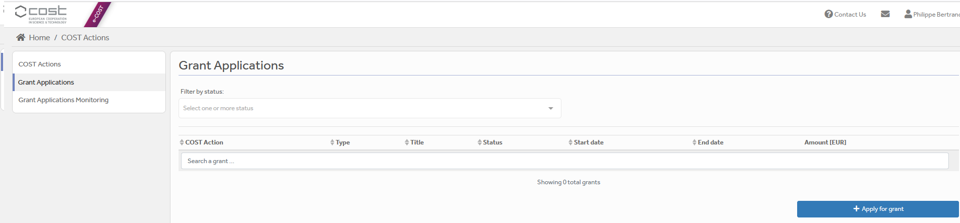

Then click on “Continue” on “VM grant”, to encode a new application.

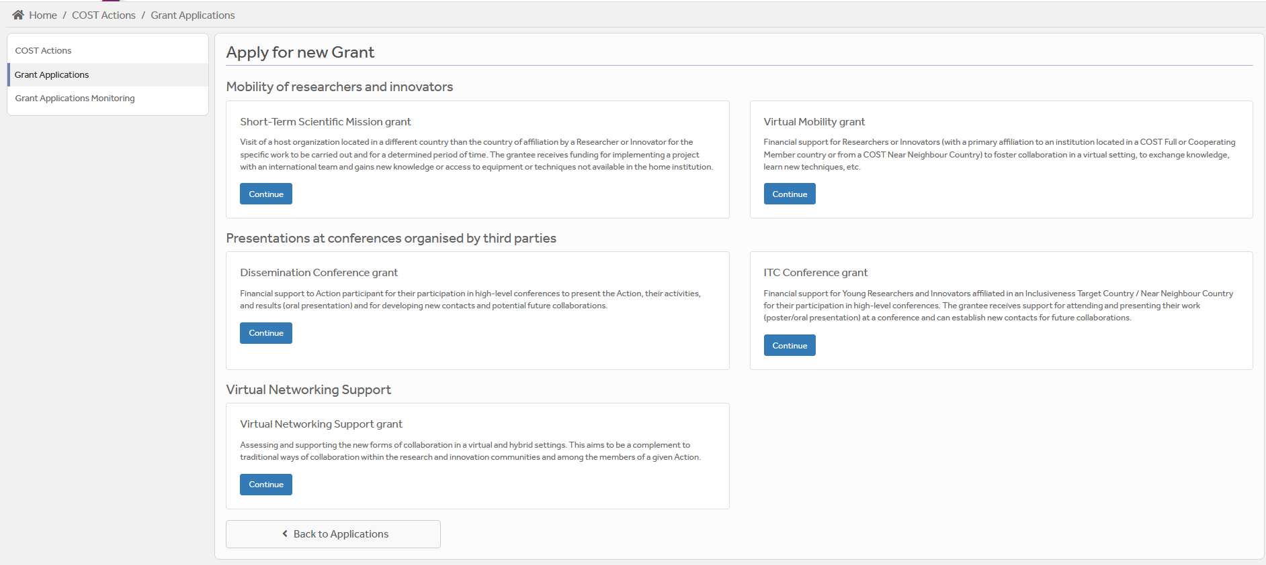

Then you just need to fill the online form with the following information:

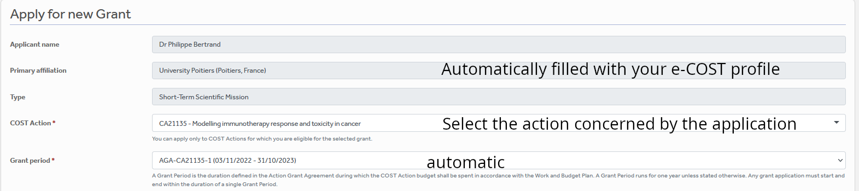

VM



After “Save Draft” you reach the “Supporting documents” page. Here you need to mention the title of the file you will submit, the type and upload the file. Upload all the requested documents that includes:

* The Grant application form modified
* A CV

Once all the documents are loaded, the applicant should click on “**Submit**”, a new window will appear and clicking on “**Options**”, please “**download PDF**”.

Grant awarding board (GAB)

The GAB is composed of the **Grant Awarding Coordinator** (Dr. Philippe Bertrand, [Philippe.bertrand@univ-poitiers.fr](mailto:Philippe.bertrand@univ-poitiers.fr)) and representatives of the working groups. It is mandatory to select the working groups the application is related to in the additional information part of the modified grant application template as reviewers of the application will be selected in the same working group(s).

The GAB will perform the scientific assessment of the applications considering the IMMUNO-model Action scope and objectives, as well as the potential for enhancement of the research interaction between the involved parts, measured by the impact of the exchange expected by the applicants and involved institutions.

The selection of applicants is based on the scientific scope of the VM application which must be coherent with the overall objectives of the Action. The GAB will select the successful applications.

In case of conflict of interest (i.e. applicant belonging to a commissioner’s research group), the member that is constrained in their duties will be substituted by the Action Chair or the Vice-Chair.

General criteria for evaluation of VM proposals are:

* Gender balance;
* Quality of the VM project;
* Contribution to the progress towards the Action objectives and deliverables;
* Curriculum Vitae (CV).
* Application between **September 23 2024 –** **October 21st 2024**;

**The Grant Holder will inform each approved applicant by sending a Grant Letter generated from e-COST. The applicant must return this letter of acceptance with his/her signature.**

VM reporting: Deliverables/Dissemination Report

**A template for the report can be found at the end of this document (Annex II). Original templates from e-COST are not accepted.**

**This template has been drafted in the context of our COST Action: Please follow the instructions. It should be uploaded as a word file on e-COST, not a pdf.**

**VM Conference report**

The report must be uploaded, **within 30 days from the end date of the VM mission** **and before October 23 2024 via e-COST tool**. Other documents to be provided are:

Any links to numeric materials produced as deliverables during the mission;

**The report is drafted by the applicant (see Annex II).**

When preparing the scientific report please consider the following:

* The networking report for COST is a public document. Please take this into account in terms of Intellectual Property Rights.
* The report should focus on the networking aspects, in particular how the numeric tools developed will contribute to future collaborative research within the framework of Cooperation and Science in the European Union.

**VM dissemination report**

**To be included in the VM report (see Annex II for ideas on items to provide) or send the items directly to the Working Group 5 Leader Barbara Breznik (barbara.breznik@nib.si) and to Working Group 5 Co-leader Rosalinda Sorrentino (**[**rsorrentino@unisa.it**](mailto:rsorrentino@unisa.it)**) within 30 days after the end of your VM mission and before October 23 2024.**

A s**hort blog / success story (3-4 sentences) /video (max. 1 minute)** describing the subject of your communication including **a strong advertising sentence** summarizing your VM Conference experience. This material will be used for promotion of our COST action in our web site and social media.

Your **credentials in social media** (if you have such) to tag you in publication of your post.

Please remember to present your passion for science! Use pictures showing you at work but also after-work. Do not sound too abstract, avoid scientific jargon, use short sentences. The material is to advertise IMMUNO-MODEL COST research, promote you, and will be shown in social media for public audience.

**Failure to submit the Conference & dissemination report materials, certificate of attendance and book of the Conference within 30 days from the end date of the mission and before October 23 2024 will effectively cancel the Grant.**

***By applying for this grant, the participant acknowledges that he/she is aware that his/her data and dissemination material will be collected, stored, processed and used for the purposes of the activities of the IMMUNO-model COST action CA21135 in accordance with the General Data Protection Regulation (GDPR).***

VM grant management

Prepare your budget with the Excel tool provided in the modified Grant application template (Annex I). This tool is provided only to help the applicant to define the budget. Each successful VM applicant will be granted based on a fixed amount.

A VM Grant is a fixed financial contribution which takes into consideration the budget request of the applicant and the outcome of the evaluation of the VM application (1500 euros max). **Please note that VM Grants do not necessarily cover all expenses related to undertaking a given mission**, being only a contribution to the overall work of the Grantee. Applicant should use the Excel tool provided in the modified Grant application form.

Grants are paid by the Grant Holder Institution after the completion of the activity and approval of all required report/documentation. Within 30 days from the end date of the VM mission (or 15 days after the end of the Grant Period, whichever date comes first), the successful applicant must submit the **VM report** and the **dissemination materials.** These documents must be uploaded on e-COST to proceed with the request for payment.

**Pre-payment**

VMs grantees may request up **to 50% pre-payment of the approved grant.** This amount is subject to availability of funds and approval by the Grant Holder Institution. The request of pre-payment shall be submitted to the Grant Holder Manager ([ghm_immunomodel@igtp.cat](mailto:ghm_immunomodel@igtp.cat)) and the Grant Awarding Coordinator (Dr. Philippe Bertrand, [Philippe.bertrand@univ-poitiers.fr](mailto:Philippe.bertrand@univ-poitiers.fr)).

**VM contacts**

|  |  |
| --- | --- |
| **Dr. Philippe Bertrand**  **CA21135 Grant Awarding Coordinator**  Institute of Chemistry for Media and Material  University of Poitiers  4 rue Michel Brunet TSA 51106  86073 Poitiers cedex 9  France  **Philippe.bertrand@univ-poitiers.fr** | **Prof. Dr Leticia Oliveira-Ferrer**  **CA21135 Action Vice-Chair**  Department of Gynecology  University Medical Center Hamburg-Eppendorf  Martinistrasse 52  20246 Hamburg  Germany  **ferrer@uke.de** |

Annex I VM Application Form Template

Action number:

VM grant title:

VM grant start and end date: DD/MM/YYYY to DD/MM/YYYY

Grantee name:

|  |  |
| --- | --- |
| **Main objective of the Virtual Mobility Grant** | |
| Applicant enters max. 200 word summary here. | |
| **Working Plan:**  Description of the collaborative initiative to be implemented. | |
| Applicant enters max. 500 word summary here. | |
| **Plan for Participation:**  Indicative list of participants in the collaborative initiative (short description of their expertise and envisaged contribution). | |
| Applicant enters max. 500 word summary here. | |
| **Main expected outputs:**  Main expected results and their contribution to the progress towards the Action objectives (either research coordination and/or capacity building objectives) and deliverables. | |
| Applicant enters max. 500 word summary here. | |
| **Contribution to the COST Action Strategy:**  How will the Virtual Mobility contribute to the COST Excellence and Inclusiveness Policy[1] and to the Action plans for stakeholder engagement and promoting participation of researchers from Near Neighbour Country (NNC) and International Partner Country (IPC)[2], and to the approved virtual networking strategy, if available. | |
| Applicant enters max. 500 word summary here. | |
| **Additional information requested by the Grant Awarding Board for the evaluation process. In case these information are not provided the application can be cancelled by the board.** |
| **Working groups in relation to the project** [1] [2] [3] [4] [5] (select 2 max)  WG1 – In vitro and ex vivo cancer immunotherapy models  WG2 – In vivo cancer immunotherapy models.  WG3 – Solid tumors.  WG4 – Hematologic tumors  WG5 – Communication, events and partnering with industry.  For objectives of the working groups, please read the Memorandum of understanding: <https://e-services.cost.eu/files/domain_files/CA/Action_CA21135/mou/CA21135-e.pdf>.  Please include how the planned communication will contribute to the plan of one or more WG(s) of the Action. |
| **Estimated budget plan:** The applicant is requested to define a budget to explain the requested amount.  Double-click the table to edit the embedded excel sheet. Fill only greyed boxes. Current data are to illustrate the automatic calculation. (If not working contact Philippe.bertrand@univ-poitiers.fr) |

Annex II Conference/Dissemination Report Template

Action number:

Grantee name:

|  |  |
| --- | --- |
| **Virtual Mobility Details**  Title:  Start and end date: DD/MM/YYYY to DD/MM/YYYY | |
| **Description of the work carried out during the VM**  Description of the virtual collaboration and activities carried out during the VM, with focus on the work carried out by the grantee. Any deviations from the initial working plan shall also be described in this section.  Grantee enters max 500 word summary here. | |
| **Description of the VM main achievements and planned follow-up activities**  Description and assessment of whether the VM achieved its planned goals and expected outcomes, including specific contribution to Action objective and deliverables, or publications resulting from the VM. Agreed plans for future follow-up collaborations shall also be described in this section. | |
| Grantee enters max 500 word summary here. | |
| **Short report for dissemination purposes. Examples of items to be added in the scientific report or send directly to Barbara Breznik (barbara.breznik@nib.si) and Rosalinda Sorrentino (rsorrentino@unisa.it)**  ***The participant acknowledges that he/she is aware that his/her data and dissemination material will be collected, stored, processed and used for the purposes of the activities of the IMMUNO-model COST action CA21135 in accordance with the General Data Protection Regulation (GDPR).*** | | |
| short blog / success story (3-4 sentences) | | |
| Examples of pictures to add | | |
| Add picture caption: Myself at hub center… | Add caption: Myself discussing network structure with the team… | |
| What Are Data Structures? {Classification & Types} | phoenixNAP KB  Add caption : structure of the data and their links |  | |
| Link to material to be downloaded (e.g. powerpoint, videos, links to network hub; pictures at high resolution…) | | |
| credentials in social media, if applicable | | |

1. <https://www.cost.eu/who-we-are/cost-strategy/excellence-and-inclusiveness>
2. As described in the Action Memorandum of Understanding (MoU)